TUTORIAL: DELTA GLIDER TO ISS
By José Pablo Luna Sánchez. 2007.
With this tutorial you will understand how to take off from Cape Cañaveral to reach ISS.
This is not really a tutorial about how to understand MFDs (that's what's the Orbiter manual for).
This will explain graphically what you are doing when you pass through the different actions to reach ISS.
This will not explain the controls you need to pilot the craft, not basic concepts on how to pilot a plane.
This tutorial is not intended to be very basic.
It is more a tutorial to help people to understand graphically what is the general logic of going to ISS using a Delta Glider.
It provides awareness about how to understand things.
So you may excuse why this tutorial is not explaining basics of atmospheric flight.
The main focus was to understand what happens once you are in orbit, and why you do things and not only what to do.
If you want a very basic tutorial, you may visit www.orbitersim.com forums and look for Orbiter forums and then a sticky thread regarding tutorials.
There you might Orbital operations tutorial by Jared Smith, or Go Play in space tutorial.

THE ASCENT
Open the directory Checklists and start the Quickstart scenario.
Before launching the scenario, check the parameters tab and make sure non spherical gravity and gravity gradient are turned off.
Those two options would make your life harder if you are a newbie.
This tutorial describes the actions you must perform, being that those options are turned off.
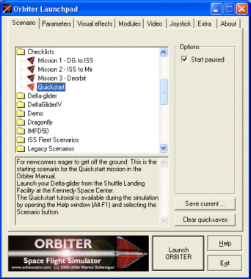
Your ship is parked on the runway, ready to take off.
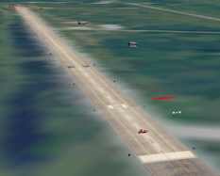
Take off and turn right to head east.
CTRL + | Increase throttle
Keypad 2 | Nose up
Keypad 8 | Nose down
Keypad 4 | Bank left
Keypad 6 | Bank right
G | Toggle gear up/down
You need a minimum velocity of 100 meters/second to take off.
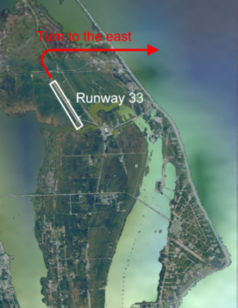
During atmospheric flight you may use Head-Up Display (HUD) in surface mode.
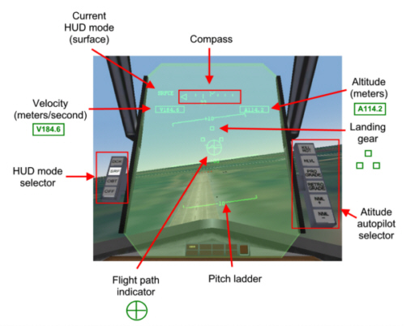
Flight path indicator tells you where your vessel is heading.
If it points to the ground, you are going towards the ground.
If you point it to the sky, you go to the sky.
Pitch ladder indicates pitch angle (angles from the horizont).
It is the replacement of artificial horizont in new planes.
Compass uses a scale from 00 to 36 (360 degrees) where
- 0 is north (appears as 00)
- 90 is east (appears as 09)
- 180 is south (appears as 18)
- 270 is west (appears as 27)
This should be your ascent plan.
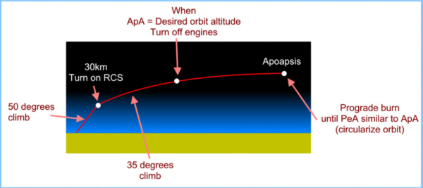
Start climbing with a pitch angle of 50 degrees until you reach 30 km.
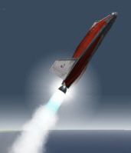
Turn on RCS engines (CTRL /) and set a pitch angle between 30 and 40.
From this point on, things will start to work les and less similar to what we are used to, or what we saw in Star Wars (Hollywood physics).
You may use keypad 5 key to activate Kill Rot autopilot to stop rotation, you it is easier to keep your nose pointing to a fixed direction.
CTRL / | Turn on RCS engines
Keypad 2 | Nose up
Keypad 8 | Nose down
Keypad 4 | Bank left
Keypad 6 | Bank right
Keypad 5 | Kill rotation
Notice that when you turn on RCS engines at 30 km, it is because wings are virtually useless becuase there is such a thin atmosphere that control surfaces are useless.
So we need those small rockets called RCS (Reaction Control System) engines to maneuver.
Here we have our craft having a pitch angle of 30 to 40 degrees (closer to 30 is better).
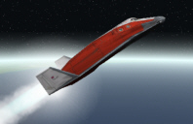
Select Orbit MFD and press PRJ and DST buttons once.
DST will display altitudes instead of distances from center of the Earth.
PRJ in SHP mode will help us to see our orbit in a non rotated view.
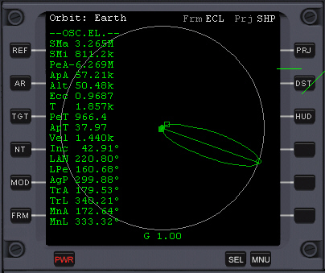
Keep your nose between 30 and 40 degrees above horizont.
When ApA (Apoapsis Altitude) is near 300 km (do not worry about being too precise here), turn off your engines.
Apoapsis is the highest point in our trajectory.
In this example, once we turned engines off, Apoapsis is 330 km above sea level.
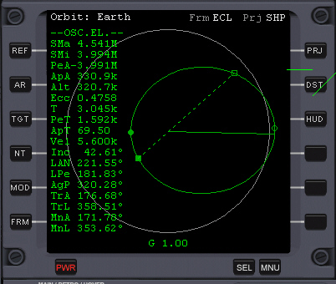
This how you may understand Orbit MFD.
Apoapsis the highest point of the orbit.
Periapsis is the lowest point of the orbit.
Nodes are points where two orbital planes meet.
In this case you have the orbit of your vessel (green line) and the plane of the orbit of Earth around sun (ecliptic).
Look at this diagram that looks as complex an advanced class of philosophy in latin.
But you may get the idea of two planes intersecting each other.
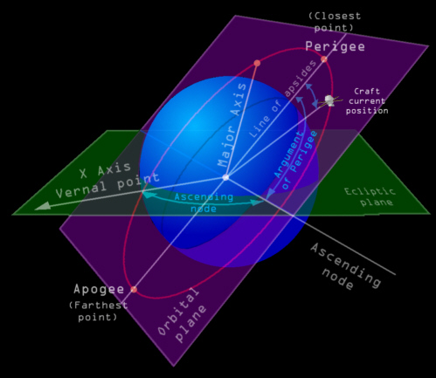
Do not worry if you don't really understand this at once.
What we need to know is that nodes are where two orbital planes cross each other.
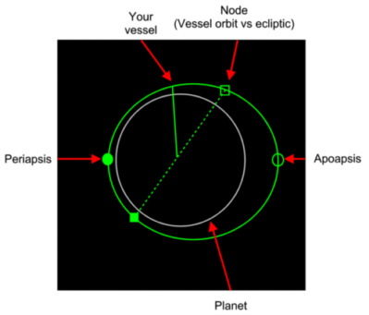
Press the Prograde button in the attitude autopilot that is to the right of your HUD.
Press the OBT button in the HUD mode selector in the left.
In this example, the nose of the ship is pointing prograde.
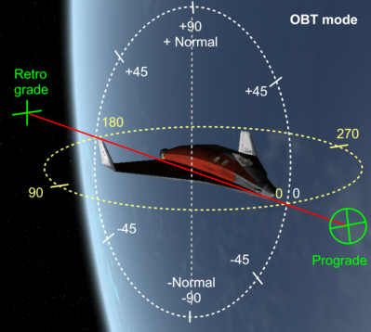
Now wait until ApT (Time to Apoapsis) is near zero, which means you reached apoapsis, and press Keypad + to raise periapsis and keep it pressed until PeA is positive and higher than 150.
This maneuver intends to raise periapsis above atmosphere.
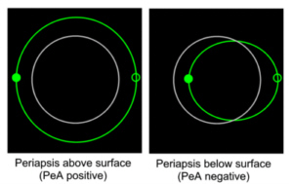
Keypad + | Turn on main engines (while pressed)
[ | Prograde
H | Switch HUD mode
Burns performed at periapsis and apoapsis are the most fuel efficient when it comes to raise or lower periapsis or apoapsis.
Knowing this is very useful for interplanetary travel too.
That's why we wait until we reach apoapsis (ApT, time to apoapsis is zero).
As you may realize, if we wait until we reach periapsis while it is under planet surface means that we crash.
If periapsis is inside atmosphere we may have aerobraking for a reentry and we want to go to ISS, not to return to Earth.
Once periapsis and apoapsis are at a similar altitude, you have a circular orbit.
When that happens, you have achieved a stable orbit.

ALIGNING ORBIT PLANES
Now that you are in orbit, we have a problem...
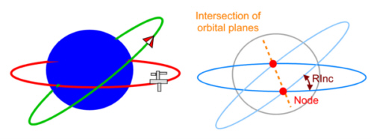
If you turn on Align planes MFD and you select ISS as your target you may see the figure of orbit alignment and you will see that RInc is not 0.00.
It means that the orbit of your vessel and the orbit of your target are not aligned.
Notice that the nodes are the points in an orbit where orbital planes meet.
Having 2 objects travelling at incredible speeds, having orbits that are not aligned might not result in a soft dock.
It would be like having 2 cars approaching to a crossroad at full speed and you try to jump from one car to another.
That would be a suicide stunt. Don't you think?
So how do we align orbits?
We make our craft to be in the same road of the other car.
It means a tight curve maneuver.
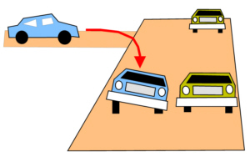
To do that in space we need to understand what is normal and antinormal.
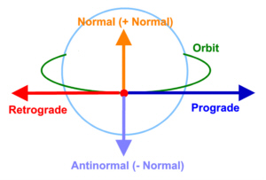
Prograde is the direction of your movement.
Normal an antinormal are directions that are perpendicular to the direction you move, and they are parallel to the planet surface.
Normal points somehow in a northern direction, and antinormal in southern direction.
Notice that if the orbit is inclined, normal and antinormal will not point exactly to the north or south.
The plane alignment maneuver is like changing from one road to another, near the crossroad, but you do it while skating on ice.
In this example RInc is 90 degrees, so we can have a better idea of what happens when we align orbits.
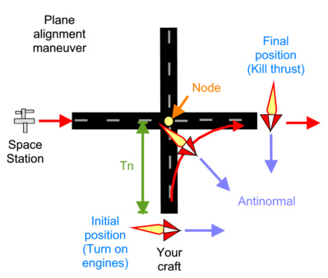
You have the space station travelling in one of the roads, going right, and your vessel in the other going upwards in this diagram.
In this example we need to burn while pointing the nose in antinormal direction.
Align planes MFD will tell you when to engage thrusters and when to stop.
Sometimes it tells you to kill thrust while RInc is not 0.
That happens because you need to get closer to the next node so the maneuver is completed effectively.
Notice that Tn is the remaining time to reach the node (the crossroad).
The node is places exactly in the crossroad.
There are two nodes:
- AN (Ascending node): Point where your orbit meets target's orbit, while your craft goes to the north.
- DN (Descending node): Point where your orbit meets target's orbit, while your craft goes to the sorth.
There is an easy trick to know the proper orientation for your alignment burn.
AN stands for Ascending Node, and also for AntiNormal.
So if you get closer to Ascending node, point your nose Antinormal (also known as "-Normal").
If you get close to Descending node, point your nose +Normal.
In the right side of the HUD you may see button NML+ (normal) and NML- (antinormal).
These will engage either normal or antinormal autopilots.
Keypad + key will engage engines.
You must make RInc to be about 0.01.
If you are a beginner, that will be tough.
Here you can see that your ship (P) is getting closer to descending node (DN).
There is a message "Kill thrust", which means that you must not use your engines yet.
In the map of the right, the node is where the two orbits cross each other.
As you may notice, in that closer node you are traveling towards the south and that's why it is called "Descending node".
Notice that in this example RInc is 53.60 degrees, which is too much.
Plane alignment is the orbital maneuver that use to be more fuel consuming, so if you plan future trips, try to minimize plane alignment.
In this example Tn is 375.5, which means that it will take 375.5 to reach the next node, which is descending node here.
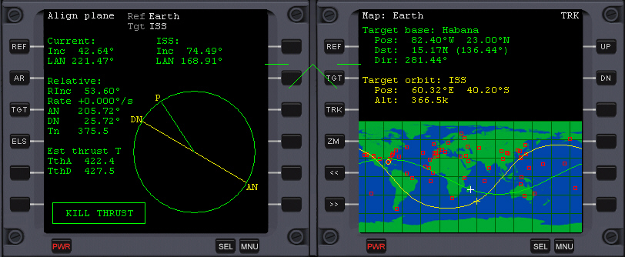
As you get closer, Align plane MFD will tell you to engage your engines, and in this example it tells you to make your craft to point in Normal (+) direction.
After some time, Align plane MFD will tell you to kill thrust, so you must disengage engines.
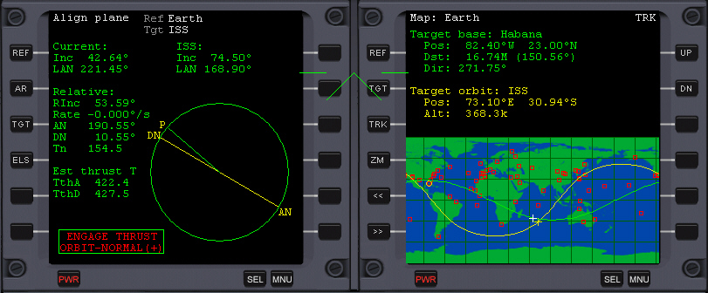
Once your RInc is 0.01, your orbit would be mostly aligned.
In the map you can see both orbits looking like a single orbit.
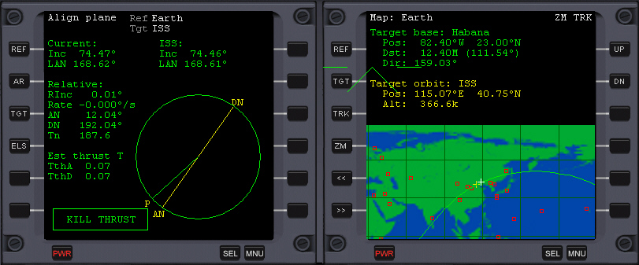

SYNCRONIZING ORBITS
Sync Orbit MFD helps you in the maneuver of syncronizing, which is the process to get closer to your target.
You already have aligned your orbit, so we are ready for syncronizing orbits.
First we need to understand Kepler's law.
It says that an orbiting body will cover equal area in equal period of time.
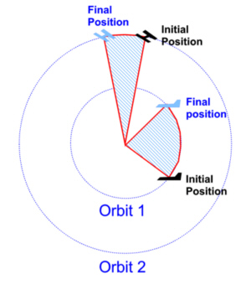
Therefore, an object flying lower will look like it travels faster than a higher object.
So by changing orbit altitudes we may get closer to an object.
Here are the posible scenarios we have when we see Sync Orbit MFD.
Your orbit will be green and your target orbit will be yellow.
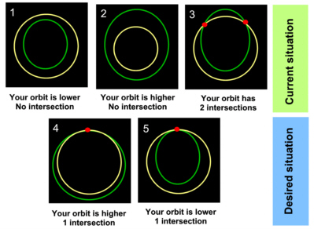
Now we see several situations.
How do we change your orbit to achieve the desired situations?
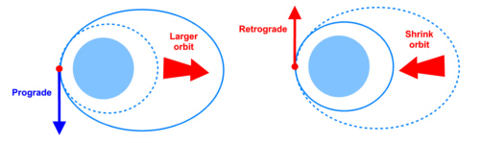
When you fire your engines in prograde direction, orbit will be larger in the opposite side.
If you fire prograde, you shrink the orbit in the opposite side.
This is why orbital maneuvers are opposite to maneuvers in a road.
In a road, if you want to reach a car in front of you, you accelerate, and if it is behind you, you brake.
But the exact opposite happens in space.
As you "brake" (fire retrograde) you are lowering your orbit and going faster, so you are not braking.
As you "accelerate" (fire prograde) you are making your orbit higher, so you go slower, so you are not accelerating.
That's why you do not say accelerate or brake (as car drivers would say), but fire prograde or retrograde.
It will take some deal of time to get used.
Things in space are not very intuitive.
Now the question is... WHEN do I change my orbit?
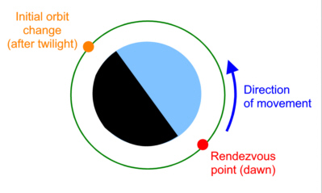
The answer is... after twilight, you either maneuver prograde or retrograde to leave a single intersection point (Rendezvous point).
In this initial orbit change maneuver we need to have a single rendezvous point.
That rendezvous point should be located at dawn (the opposite side of the planet), so you have 1 hour of daylight to perform your final approach and docking.
You may not want to dock at night, you have no flood lights.
After that, any upcoming burn would take place at the rendezvous point only.
Now let's analyze what to do in detail in every case.

