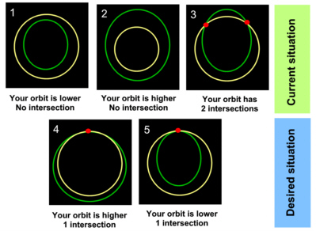
- Case 1: Burn prograde, you are lower than your target. You might get a situation 5.
- Case 2: Burn retrograde, you are higher than your target. You might get a situation 4.
- Case 3: Try to circularize your orbit first, making the burn at the apoapsis or periapsis, so you have situation 1 or 2.
Notice that when PeT (Time to Periapsis) or ApT (Time to Apoapsis) are zero in Orbit MFD it means you have reached periapsis (PeT = 0) or apoapsis (ApT = 0).
There are more efficient ways, but those could be very hard to understand by a newbie.
Notice that if your orbit is below the station, you need to be careful, so the altitude of periapsis (PeA in Orbit MFD) is not under 150 km above sea level.
Once you have case 4 or 5, the only burns you will do will be prograde or retrograde, and you only will do that at the intersection point.
The goal is to make DTmin data in SyncOrbit MFD to be close to zero (0.01 would be fine).
If you are playing with realistic settings, you may notice that sometimes your intersection point disappears and your RInc (remember alignment maneuver) changes.
That's because Sun and the Moon will be pulling your craft and changing your orbit.
It is annoying, I know.
Gravity isn't easy, but it's the law...

Understanding Sync Orbit MFD
Ok, you got the instructions, but you do not understand the instruments...
This how they work.
When you syncronize orbits it is better to have Orbit MFD and Sync Orbit MFD.
In Orbit MFD you can check your periapsis (PeA), so it keeps ouside of atmosphere.
If you see PeR instead of PeA, press DST button.
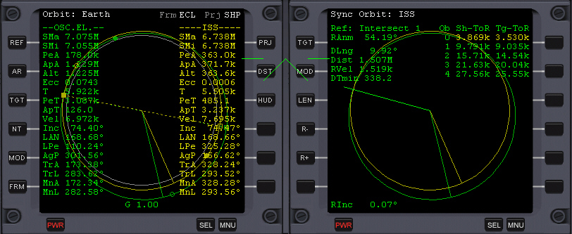
Sync Orbit MFD has 2 columns with numbers.
Understanding this is very hard for people who are not used to the concept of syncronizing.
Let's see what each label means:
Sh-ToR: Ship - Time to Rendezvous
Tg-ToR: Target - Time to Rendezvous
Dist: Distance to target
DTMin: Delta Time minimum (This figure is very important, and I will cover it soon).
RInc: Relative Inclination (we already covered it when we aligned orbits)
Ob: Orbit
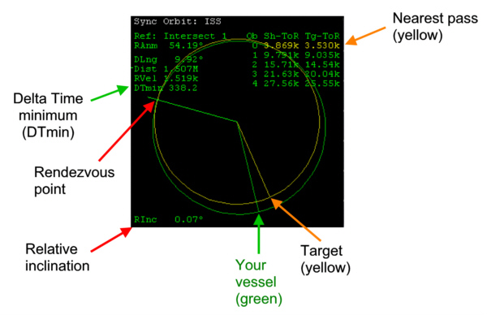
If you are turning and turning, you will make several orbits around Earth.
You pass through the intersection point many times.
Sh-ToR tells you how much time you need to wait to pass through the intersection point.
But since you pass many times, you have several numbers.
In this example, you may see that you need to wait for 3.869k seconds (3869 seconds) to reach intersection (rendezvous) point.
After that you will pass another time though the intersection point and you need to wait 9.791k seconds from now, to pass a second time.
And so on.
The column Tg-ToR says the same but for your target.
The difference between Sh-ToR and Tg-ToR is the time gap between the moment when you and your target pass through intersection point and we call it DT (Delta time).
If you calculate the differences for all orbits listed, one of them will be smaller (and we call it DTmin) than the rest.
If DTmin is zero, it means that your ship and your target reach the intersection time in the very same moment, and this is what we want.
The yellow number indicates which orbit has the lower DT (DTmin).
So you need to wait until then.
Remember that once you have a Rendezvous point, you only fire prograde and retrograde at the rendezvous point.
As you do that, you will notice that there are several possible orbits that allow you to have a DTmin equal to zero.
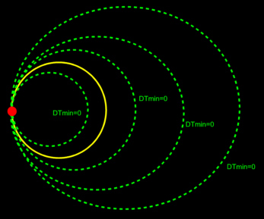
You also may change the amount of numbers listed (up to 19) in the Sh-ToR column, and then you might find that the orbit with the lowest DTmin may change, because you have more orbits to choose a DT from.

Setting up frequencies prior to rendezvous
Now that DTmin is zero, it is a matter of waiting as you go around several times until you reach (or be reached) by your target.
You may use that time to switch HUD to Dock mode and setup the frequencies of your space station transponder, as well as the frequency of the beacon signal of the docking port of the station in COM/NAV MFD.
Dock button is in the left side of the HUD, and it is called DCK.
You need to press F4, then Object info, and ten select Vessel and then ISS.
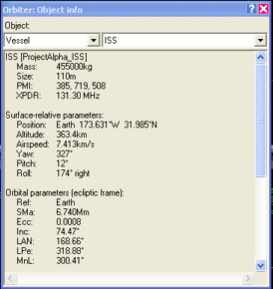
You have XPDR and IDS frequencies.
XPDR is the transponder, an emitter that helps us to locate our target in the distance, and allows us to have a target designator in our screen.
IDS frequencies are the frequencies to approach a docking port.
Use those data when setting a frequency in COM/NAV MFD.
If we do not set those frequencies, we will not be able to see our target in Dock HUD mode when we get close.
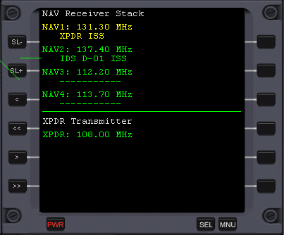

RENDEZVOUS
Before attempting to perform a rendezous maneuver let's understand HUD Dock mode.
Understanding this may avoid confusion, becuase approaching to the station is a bit hard.
These are the keys you will need:
H | Toggle HUD modes
Keypad / | Toggle ROT/LIN RCS mode
Keypad 5 | Kill rotation
ROT mode
Keypad 2 | Pitch up
Keypad 8 | Pitch down
Keypad 4 | Bank left
Keypad 6 | Bank right
Keypad 1 | Yaw left
Keypad 3 | Yaw right
LIN mode
Keypad 2 | Move upwards (+Z)
Keypad 8 | Move downwards (-Z)
Keypad 9 | Move backwards (-X)
Keypad 6 | Move forward (+X)
Keypad 1 | Move port/left (-Y)
Keypad 3 | Move starboard/right (+Y)
Here I used the vessel axis used by NASA manuals.
If you ever decide to become an Orbiter developer you will realize that Orbiter axis are different.
But for common users who pilot, that difference is not relevant.
So you may get used to NASA manuals axis if you want to follow real NASA checklists.
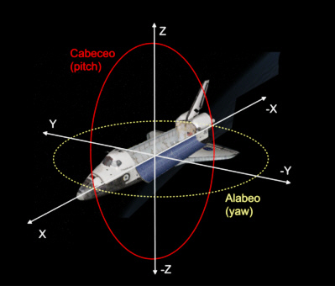
Use H key to switch modes or use the DCK button that is to the left of your screen, to set HUD Dock mode.
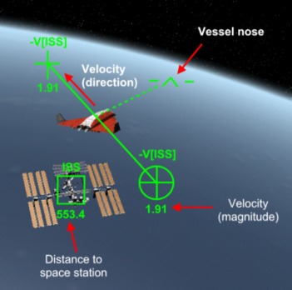
You have several symbols that indicate different things.
The + symbol indicates the direction of your motion, relative to the station (if you were in a fixed point relative to your station, your relative velocity would be zero).
Notice that your nose may not be pointing in the direction of motion.
The magnitude of the velocity indicates how fast you are moving.
If magnitude was zero or near zero, you would be fixed in space relative to the station position.
If at some point you want to brake, you need to point your nose towards the circle with the cross inside and turn on your engines.
If the + sign points towards the station, it means you are approaching the station.
But unlike Star Wars, you will see how the + sign starts to move in time.
Blame Kepler's law, for even if you have a few hundred meters of diference in altitude, Kepler's law is still working.
So what many people do is to point the + towards station and use linear thrusters to compensate.
Other people do is to point the + towards the station and fire, and after some time they brake (velocity magnitude to zero) and then start over again.
This is not the most efficient way to move when you are closer to the station.
This is Star Wars maneuvering
In real life pilots should never fire their engines towards space stations, for they are very powerful and they could damage the station.
So they try to use inertial velocity to the most of the job for them.
Let's see these cases.
You may be above or below the station.
You may be ahead or behind the station.
Velocity represents the direction where the + symbol should point.
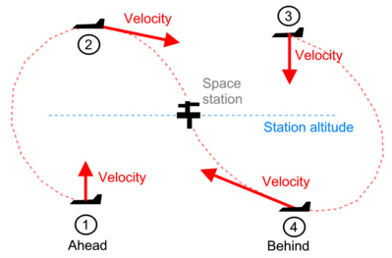
Situation 1: Ahead and below
Point + symbol upwards to gain altitude.
You will end being above, in situation 2.
Velocity symbol (+) seems to move closer to the station.
You will need to make it to point above the station.
Situation 1 ends once you reach station's altitude, and the situation 2 starts.
Situation 2: Ahead and above
Point + symbol backwards, just above the station.
The + symbol will move towards the station.
Situation 3: Behind and above
Point + symbol downwards to lose altitude.
You will end being above, in situation 4.
Since you are above, you go slower, so you need to lose altitude if you ever try to reach the station.
The velocity symbol (+) will move away from the station as long as you are above.
This situation ends when you reach station altitude and then situation 4 begins.
Situation 4: Ahead and above
Point + symbol forward, just below the station.
The + symbol will move towards the station.
It will take a little practice to get used to Kepler's laws.
This is definitely not Star Wars physics, but very unintuitive physics for us.
And it becomes worse when we make our rendezvous time to become longer.
In the diagram above we have station altitude as a straight line, but when you go around in orbit, it becomes a curved line.
So if you planned your rendezvous to take place after several hours, it is probable that this diagram is not of much help to you.
So you may need to download Rendezvous MFD from www.avsim.com
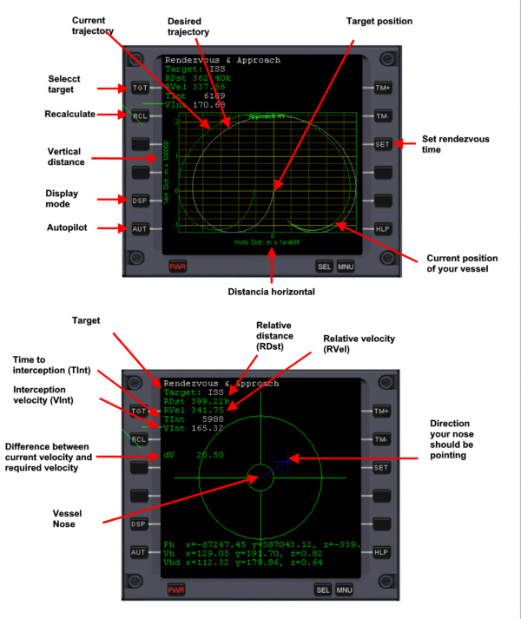
This MFD has a similar representation like the one I used above.
The target is located in a fixed point and you measure vertical and horizontal distance between your craft and your target.

Understanding instruments
When you have your target in front of you, you may see a box as target designator and the distance to the target under it, when HUD is in docking mode and you are closer than 500km..
The + symbol is visible here, so it means that you are getting closer to your target.
As you may notice, in this example the craft is flying above and the + symbol is above the station too.
We also see that the vessel is inverted.
We also see RCS ROT, which is the rotation mode.
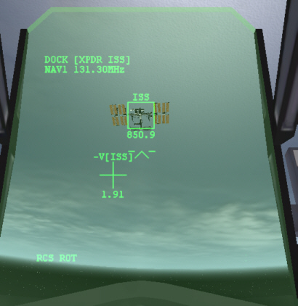
When the target goes off the screen there will see an arrow pointing towards it.
When the velocity symbols (either the + symbol or the circle with a cross inside) are off the screen, there will be an arrow pointing towards the circle with the cross.
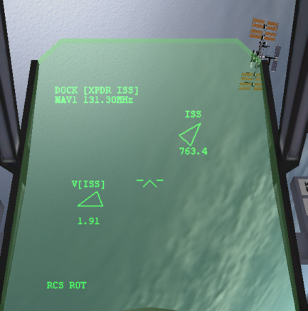
When you intend to reduce your relative velocity you need to point your nose towards the circle with a cross and then fire your engines.
In this example, the nose is not yet aligned.
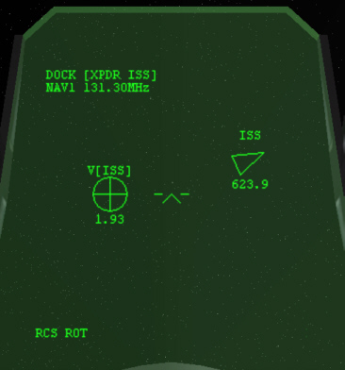
Once you can see the station, press CTRL R to turn on the approach gate view.
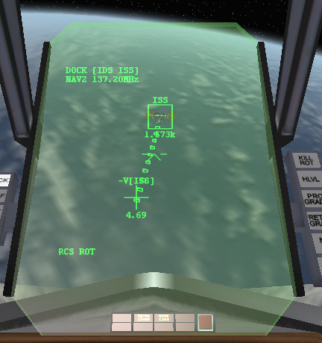
Use your engines in LIN mode to point at the end of the gate.
Keep pointing there, and when you reach there, continue with the steps to dock.

DOCKING
When you are about to dock, seeing space station through the window is not the best view.
You better use Docking MFD.
This a slow move, so you need to be patient here.
Being in a hurry is the best way NOT to get where you want.
It is hard for people to gain awareness about what each element means in this MFD.
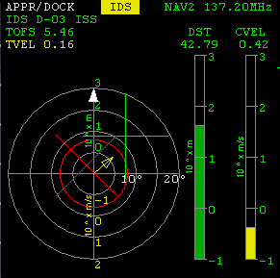
CVEL means the velocity of approach.
In real dockings it should be lower than 0.1 but here we will be happy if we achieve that with CVEL lower than 1.
Even at that velocity you may think it takes forever to dock.
DST is the distance between you and your vessel.
The red X aligned with the center of those concentric circles means that your docking port is pointing in a parallel direction respect to station docking port.
Use engines in ROT mode to align, and keys 1, 3 and 2, 8 of your keypad.
Once you do that, try using keys 4 and 6 of your keypad to make the "this side up" arrow to point upwards.
Then switch to LIN mode and make the yellow arrow to move towards the green +, until the + points to the center.
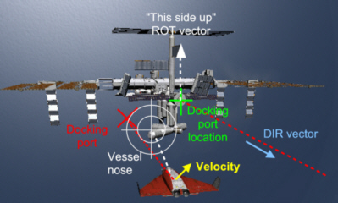
If you did that, you are aligned.
Now you may start your approach.
Keep your engines in LIN mode.
Use keypad 6 and 8 to move.
You may use CTRL 6 and CTRL 8 (use the numbers of the keypad) to fine tune your engines in forward and backwards direction respectively.
Use keypad 2 and 8, and keypad 1 and 3, to keep the green + in the center or the MFD.
Following these steps you should be docked soon.
As you dock, you feel a great sense of achievement.
If you didn't dock, it doesn't matter.
The joy of facing something new and never surrendering in the adversity is what will make you to be successful some day in the near future.
Congratulations!!

