Saturday, 28 February 2009

How To: Disassemble a LaCie Little Disk – Photo Guide
While looking for a disassembly guide for the LaCie Little Disk 320GB so that I could use the SATA hard drive within to replace the faulty and failed hard drive in my Acer Aspire One netbook, I read many reports that it was very difficult and gave up trying to find a guide.
Instead I decided to look at it logically, and found it to be very simple. Here is how to disassemble the LaCie Little Disk 320GB.
1. Here is the LaCie Little Disk, its just a little bit scratched and there are a few fingerprints, but otherwise it is a very nice looking device. | 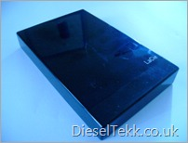
2. Remove the front cover and set it aside, now take a look at the what you see. You will find a tiny notch just at the seam as indicated in the photo. | 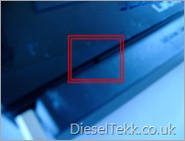
3. I used a penknife for this, but any similar, flat bladed item will do, such as a credit card. Insert your chosen blade between the two housings just above the notch, be gentle. Now, twist it slightly until you hear a pop like noise. This is simply the glue separating from the two housings. | 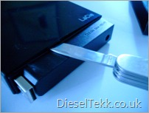
4. Slide the blade along to the right until it stops, then give it another twist as before. Once again you should hear the same pop. Now, slide the blade back along to the left and do the same. | 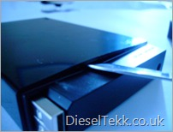
5. Flip the drive over and repeat the process on the other side. Once you have done this, you are ready to pull the drive free of the housing. Give it a good, firm tug. | 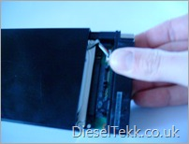
6. I forgot to take a photo of the drive with this rubber band attached, but here it is set aside. If you decide to reuse the caddy, perhaps with a smaller capacity drive, then make sure you take notice of where it is situated, you will need to put it back on. [UPDATE – As you may read in the comments, not all LaCie Little Disk’s have this rubber band] | 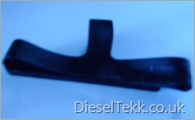
7. You will need to remove these two screws to remove the SATA/USB converter PCB. | 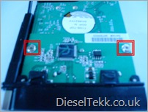
I replaced the 320GB drive in this caddy with a smaller 80GB drive from an old laptop. When I put it all back together it worked fine.
And that is all there is to it, it’s really no more than a 10 minute job at most. Of course, I have to say at this point that if your drive does not work after you have carried out these instructions then you must not hold me responsible, it’s your drive, your warranty and your responsibility!
Have you found this LaCie Little Disk disassembly guide useful? Would you like to share it with others – just use the icons below? Please leave your comments below.
Technorati Tags: Netbook,LaCie,Little,Disk,Photo,Guide,SATA,Acer,Aspire
Windows Live Tags: Netbook,LaCie,Little,Disk,Photo,Guide,SATA,Acer,Aspire

