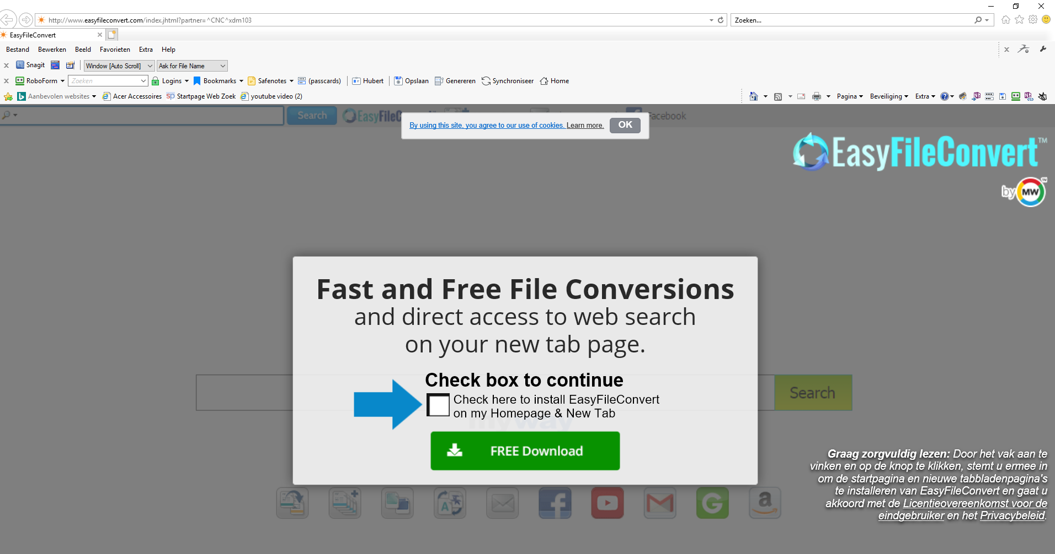

http://www.easyfileconvert.com/index.jhtml?partner=^CNC^xdm103

